Spiral

Today's game is called Spiral, and it's perfect for fifth graders, but there are variations for mathematicians of all ages.

Skills Focus: Multiplication (or other operations if you'd prefer)

How to Play: The object of this game is to be the first to travel from start to finish.

Start with a complete deck of cards, as well as 1-2 dice and game pieces for each player. Ace = 1, Jack = 11, Queen = 12 and King = 13.

To begin, build a spiral out of the entire deck of cards, as shown in the picture below. This will serve as your game board. You can use the same board for multiple games, or create a new board each time to change it up.

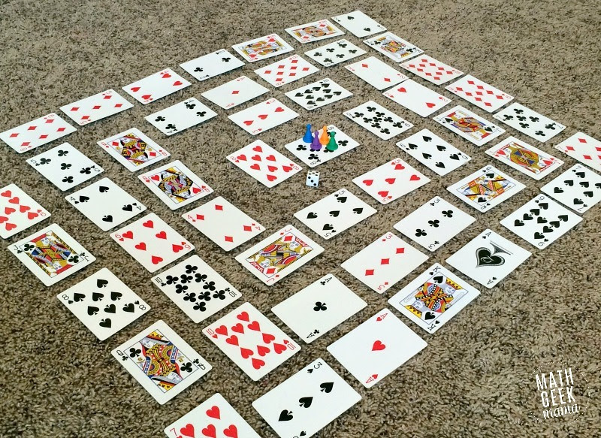
Each player then places their game piece at start (the center of the spiral).

To start, the first player rolls a die and moves that number of cards on the game board.
They must then multiply the number on their die with the value of the card they landed on. If they solve it correctly, they stay there, otherwise they go back to their previous position.

Players then take turns rolling and moving around the game board.

If a player lands on a card with another player on it, they "bump" that player back to start.

If a player lands on a "double," meaning the number on their die and the value of their card is the same, they get to go again.

The first player to land exactly on the last card and correctly solve the multiplication problem wins!

Variations:
For younger kids, try one of these variations:
- You could change the operation to addition or subtraction (or even just practice number recognition by removing all face cards).

- Change the spiral to facedown and play with one die. Use the die to recognize numbers and travel the pathway by number of dots on the dice.

- Change the spiral and play with one die. When the player lands on a card, it is turned over and must be named correctly. (Decide whether or not to leave in the ace and face cards.)
For more experienced mathematicians, try one of these variations:
- If you'd like to focus on multiplying by 10, change the value of all face cards to equal ten or leave them as they are to multiply by 10.

- If you’d like to multiply (or divide) by powers of ten, use only one die and use it as the factor and the power of 10.

- Adjust the rules so that an opponent must specify what operation to use when combining the die and card.

- For very experienced players, change the value so the value of the black cards represents positive integers and the red cards represent negative integers.

For all players, try these:
- To shorten the game, adjust the number of cards used to build the spiral or eliminate the requirement to land exactly on the last card to win.

- If a player lands on an occupied space, if the problem is solved correctly, the other player goes back to start. If the player who rolled is wrong, that player returns to start.

