Tour the USA

Today's game is called Tour the USA, and it's perfect for kids of any age to work on math operations and the States and capitals!

Skills Focus: Addition, Subtraction, Multiplication or Division PLUS State Capitals and Abbreviations.

How to Play: The object of this game is to go to all 50 states by solving math problems.

To begin, you will need a printed game board and recording page for each player.

Then shuffle a complete deck of cards. Ace = 1, Jack = 11, Queen = 12 and King = 13.

Place the cards face down on the game board on the "pack" place.

Players take turns drawing two cards and solving the problem using whatever operation you decided to work on.
For example, if you're practicing multiplication and draw a 5 and a 7, you would have to solve 5x7.

If the player solves it incorrectly, the turn is over. If the player solves it correctly, a marker can be placed on the first state in alphabetical order. (Use the map below or use one you have at home. If a state is too small for a marker, place it on the name of the state.)

Players continue taking turns and moving through the states (in alphabetical order, if it is age appropriate) until someone completes all 50, or time is called.

The first player to reach all 50 states (or the player with the most states at the end of the time) is the winner!

Variations:
- Change the rules so a player needs to solve the math problem (not everyone has to use the same operation), name the next state and give the capitol.

- Change the scoring rules. One point for correct answer, one point for correct state, one point for correct abbreviation, one point for correct capitol.

- Draw four cards to make two fractions to add, subtract, or multiply. Again, young players may not be able to compute fractions, so they could continue to select two cards to add, subtract, multiply, or divide.

- Select the operation to be used before each turn (before cards are drawn).

Discard
Pile
Facedown
Pack
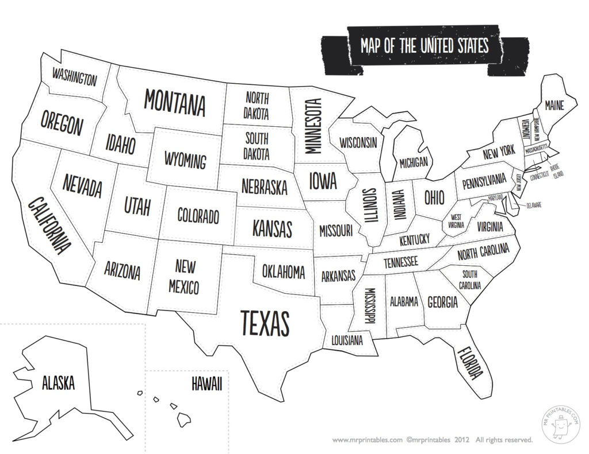

Score Sheet (optional)
Round | Cards Drawn | Answer | State Name | Abbrevi-ation | Capital | Score

Score Sheet (optional)
Round | Cards Drawn | Answer | State Name | Abbrevi-ation | Capital | Score

